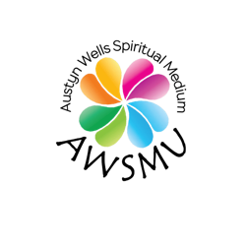

Soul Keys
Exploring the Archetypes of Your Soul

The first metaphysical tool I explored was the tarot. Although there are 72 cards in a tarot, the 22 Major Arcana cards stunningly depict our human journey and are rich in symbology, metaphor, mystical associations, and wisdom.
We will step into the doorway of each card to heighten your intuition, unlock your unconscious, and offer you with a timeless language which opens new communication lines between your soul and the Universe.
Through journaling, discussion, group exercise, sacred play, mediation and intuitive readings, you will be empowered to:

- Richly understand each card of the major arcana
- Gain confidence using cards to read for other people, including yourself
- Learn the astrological, herb, gem, animal, mythology, color and musical associations of each card
- Speak the symbology of the tarot. (The spirit world used these symbols to deepen my ability to communication intuitively and mediumistically)
- Illuminate your own journey through the metaphors of the Fool’s journey
- Deepen your meditation and spiritual practice

All classes will be on Zoom. Should you be unable to attend class, the link will be made available to you so you will not miss any content.
Please feel free to email me should you have any additional questions.

